# Changes in kelp forest communities along the coast of Washington, USA during and after the 2014-2016 marine heatwave and sea star wasting syndrome

Tolimieri1*, Nick

Shelton1, Andrew O.

Samhouri1, Jameal F.

Harvey1, Chris J.

Feist1 Blake E.

Williams2, Gregory D.

Andrews1, Kelly S.

Frick3, Kinsey E.

Lonhart4, Steve

Sullaway5, Genoa

Liu1, Owen

Berry6, Helen D.

Waddell7, Jenny

1Conservation Biology Division, Northwest Fisheries Science Center, NOAA Fisheries, 2725 Montlake Blvd E, Seattle WA 98112

2 Pacific States Marine Fisheries Commission, under contract to Conservation Biology Division, Northwest Fisheries Science Center, National Marine Fisheries Service, National Oceanic and Atmospheric Administration, 2725 Montlake Blvd E., Seattle, WA 98112, USA.

3Fish Ecology Division, Northwest Fisheries Science Center, NOAA Fisheries, 2725 Montlake Blvd E, Seattle WA 98112

4Monterey Bay National Marine Sanctuary, National Ocean Service, National Oceanic and Atmospheric Administration, 110 McAllister Way, Santa Cruz, CA 95060

5College of Fisheries and Ocean Sciences, University of Alaska Fairbanks, 17101 Point Lena Loop Road Juneau, AK 99801

6Aquatic Resources Division, Washington Department of Natural Resources, 1111 Washington St SE, Olympia, WA 98504-7027

7Olympic Coast National Marine Sanctuary, National Ocean Service, National Oceanic and Atmospheric Administration, 115 E. Railroad Ave. Suite #301, Port Angeles, WA 98362, USA

*Corresponding author: nick.tolimieri@noaa.gov

# Abstract

Canopy-forming kelps are foundation species in many coastal ecosystems, but kelp-forest communities are subject to abrupt state changes caused by environmental drivers and trophic dynamics. We examined changes in kelp communities at five sites along the Olympic Coast of Washington State, USA during and following the recent perturbations of anomalous warm-water events and sea star wasting syndrome (SSWS). Anomalously warm water in 2013 and 2014 corresponded with a loss of approximately 50% of *Macrocystis pyrifera* and *Nereocystis luetkeana* canopy. However, the canopy quickly recovered, and stipe density increased after 2015. Purple sea urchins *Strongylocentrotus purpuratus* increased in density 164-fold, largely at one site, but this increase was first observed in 2017 and peaked in 2019, after the warm period. Sea stars did not show recovery from SSWS, with several species including *Pycnopodia helianthoides* continuing to decline. The majority of variation in assemblage structure occurred at the site level for kelps, macroinvertebrates, and fishes, while year explained most of the variability for juvenile rockfishes (*Sebastes* spp.). We did not see strong top-down effects of urchins on kelp, suggesting that top-down impacts were not dominant regionally during this period. In contrast, we found evidence for a bottom-up influence of kelp habitat on juvenile rockfishes, as rockfish recruits occurred with higher probability where kelp stipe density was higher. Our analyses highlight the importance of spatial variation in structuring changes in kelp forest communities associated with disturbance and suggest that it is essential to ensure the protection of a diversity of kelp forests.

Key Words: kelp, marine heat wave, sea star wasting syndrome, urchins, rockfish recruitment, microhabitat

# Introduction

Kelps forests are iconic nearshore habitats found in temperate and subpolar waters along approximately a quarter of the world’s shorelines (Smale 2020). As foundation species (Teagle et al. 2017, Wernberg et al. 2019), these large brown algae (primarily order Laminariales) provide biogenic habitat for many species and form the basis of highly productive, diverse and complex nearshore food webs (Duggins 1988, Duggins et al. 1989, Gabara et al. 2021, Smith & Fox 2022). Kelps influence nearshore sedimentation dynamics (Connell 2005), provide coastal protection from wave energy (Pinsky et al. 2013), and increase carbon sequestration and buffering against ocean acidification (Wilmers et al. 2012, Weigel & Pfister 2021, but see Gallagher et al. 2022). By fueling nearshore production and providing extensive juvenile and adult fish habitat, kelp forests support diverse ecological communities (Graham 2004, Schiel & Foster 2015, Teagle et al. 2017) and important commercial, recreational and subsistence fisheries for both fish and invertebrate species (Rogers-Bennett & Catton 2019). As many ecosystem-level perturbations are anticipated to intensify under scenarios of climate and ocean change (IPCC 2022), maintaining services from kelp forests requires regional, mechanistic studies to understand dynamic community responses.

Kelp forests are susceptible to state changes from kelp-dominated (i.e., kelp forests) to sea urchin-dominated (urchin barrens) habitat (Ling et al. 2015, Beas-Luna et al. 2020), which poses a risk to the wide range of the valuable ecosystem functions provided by kelp forests (Smith et al. 2021, Smith & Fox 2022). These state changes can be precipitated by climate and oceanographic variability (Pearse & Hines 1987, Pfister et al. 2018, Smale 2020), or by trophic dynamics triggered by shifts in populations and behaviors of key consumers (Ling et al. 2009, Watson & Estes 2011, Feehan & Scheibling 2014, Ling et al. 2015, Shelton et al. 2018, Dunn et al. 2021). The distribution of kelps is strongly related to ocean temperature (Breeman 1990, Smale 2020) making them vulnerable to both long-term ocean warming and the more temporally discrete effects of marine heatwaves (MHW, prolonged but defined periods of anomalously warm water; Hobday et al. 2016). For example, decadal scale warming in Japan, the Iberian Peninsula, and the Northwest Atlantic has led to canopy loss, range shifts, and loss of species in these regions (Smale 2020). Rapid loss of kelp cover in response to MHWs (Straub et al. 2019) has been documented in New Zealand (Thomsen et al. 2019), Western Australia (Smale & Wernberg 2013, Wernberg et al. 2016), the North Atlantic (Filbee-Dexter et al. 2020) and some but not all regions of the northeast Pacific (Beas-Luna et al. 2020). High SST is often associated with low nutrient conditions, which can contribute to low kelp growth or die-offs (e.g., Cavanaugh et al. 2011, Wernberg et al. 2016, Pfister et al. 2018, Smale 2020), while some studies suggest that elevated temperatures have independent physiological impacts (Muth et al. 2019, Hamilton et al. 2020). Wave action can have different impacts based on location and species life history—both impacting kelps directly and by influencing herbivore behavior (Dayton & Tegner 1984, Siddon & Witman 2003, Reed et al. 2011, Hamilton et al. 2020).

Intense herbivory by sea urchins when at high density can also drive shifts from kelp-dominated to urchin-dominated system states (Ling et al. 2015). However, kelp forests can be maintained or promoted by trophic cascades in which urchin predators depress urchin abundance thereby facilitating dense kelp stands—the iconic example being the otter-urchin-kelp trophic cascade described for the northeast Pacific (Watson & Estes 2011, Shelton et al. 2018), although fishes and invertebrates (Ling et al. 2009, Eurich et al. 2014, Selden et al. 2017, Eisaguirre et al. 2020) are important in some areas regionally and around the globe. However, these trophic relationships can be more complex than the simple trophic cascade story as predator redundancy, urchin behavior, and habitat complexity all impact the dynamics (Pearse 2006, Eurich et al. 2014, Ling et al. 2015, Burt et al. 2018, Kriegisch et al. 2019, Randell et al. 2022).

Kelp forests along the west coast of North America have experienced several major perturbations in the last decade. The northeast Pacific Ocean (Baja California to Alaska) experienced a massive and prolonged MHW, which developed in the southeast Gulf of Alaska in the boreal winter of 2013/2014, began to impact the nearshore in 2014 (hence our use of 2014 throughout as the start date), and persisted until 2016 (Bond et al. 2015, Cheung et al. 2016, Jacox et al. 2018, Scannell et al. 2020). This MHW had profound effects on both the offshore and nearshore ecosystems (Cavole et al. 2016, Lonhart et al. 2019, Morgan et al. 2019, Sanford et al. 2019, Cheung & Frölicher 2020), including substantial loss of kelp in some areas (Beas-Luna et al. 2020). The timing and intensity of the 2014-2016 MHW impacts on the nearshore environment varied with latitude, and subsequent MHWs followed in 2019, 2020, and 2021 (Bond et al. 2015, Scannell et al. 2020, Harvey et al. 2022).

Additionally, beginning in late 2013, sea star wasting syndrome (SSWS) impacted populations of at least 20 species of sea stars from California to Alaska, including the Salish Sea (Hewson et al. 2014, Montecino-Latorre et al. 2016, Hewson et al. 2018, Hamilton et al. 2021), rapidly reducing many populations by 2014 and leading to local extinctions for some species. On the outer coast of Washington, *Pycnopodia helianthoides* (hereafter *Pycnopodia)* declined by 75% prior to 2018 and had lost 99.6% of its population by 2020 (Hamilton et al. 2021). Some areas, particularly in northern California, experienced large increases in purple urchins *Strongylocentrotus purpuratus* (Rogers-Bennett & Catton 2019). As some of the hardest hit sea stars (e.g., *Pycnopodia*) consume urchins, the die-off may have reduced top-down predation pressure on sea urchins. However, urchins follow well-documented boom-bust reproductive cycles (Pearse & Hines 1987, Uthicke et al. 2009, Ebert 2010), and the dramatic increase of purple urchin populations in the early 2010s, which was temporally and spatially disjunct along the northeastern Pacific, may have been due to a combination of a reduction in a minor predator (sea stars, especially *Pycnopodia*; Hamilton et al. 2021), a change in foraging behavior due to a SST-driven decrease in available drift kelp (Kriegisch et al. 2019), and a numeric increase due to successful recruitment.

There were large regional differences in the response of kelp forests to these events. Kelp cover in Oregon was either stable or increased during and following the 2014-2016 MHW (Hamilton et al. 2020), while Northern California saw substantial and persistent loss of kelp canopy and a shift to urchin barrens (Rogers-Bennett & Catton 2019, McPherson et al. 2021). Responses in Central California and the Southern California Bight were more muted, as kelp cover declined only slightly even though there were large increases in urchins in Central California (Beas-Luna et al. 2020). In Baja California, both kelp and sea urchins decreased sharply (Cavanaugh et al. 2019, Beas-Luna et al. 2020). The regionally distinctive responses of kelp forest communities are likely due to both spatial variation in climate dynamics and associated bottom-up environmental drivers (especially in relation to species’ tolerances and range margins), and to regional differences in food web structure, in particular, top-down pressure (Reed et al. 2016, Beas-Luna et al. 2020). For example, ocean temperatures did not get as warm in Oregon as in Northern California, and Hamilton et al. (2020) did not observe loss of kelp canopy in Oregon. Additionally, the presence of sea otters *Enhydra lutria* in Central California (Gregr et al. 2020) and the combination of sheepshead *Archosargus probatocephalus* and spiny lobsters *Panulirus interruptus* in Southern California (Tegner & Levin 1983, Selden et al. 2017, Eisaguirre et al. 2020) may have provided enough top-down pressure to limit urchin densities and affect urchin feeding behavior sufficiently to prevent a shift to urchin-dominated habitats in these regions. However, in Northern California, where there was substantial warming and little predator redundancy, the die-off of *Pycnopodia* may have released urchins from top-down control, allowing their outbreak (Beas-Luna et al. 2020)

Kelp forests in California have been monitored regularly for decades, including the periods before and after the recent marine heatwaves, sea star die-off, and localized changes in kelp-urchin dynamics (Rogers-Bennett & Catton 2019, Beas-Luna et al. 2020). However, kelp forests along the outer coast of Washington, USA (Fig. 1), have received only sporadic attention. Past studies have documented recovery of kelp and declines in invertebrate abundance following the restoration of sea otters, a keystone predator, to the Washington coast with otter populations initially reintroduced in 1969-1979 and then increasing rapidly between the 1980s and 2010s (Kvitek et al. 1989, Kvitek et al. 1998, Shelton et al. 2018). Less is known about interannual dynamics, including how kelp forest sites in Washington have changed following recent major perturbations. Moreover, little is known about the ecology of fish communities in these kelp stands, despite the important role of kelp habitat in the life history of multiple commercially important species in the region. For example, many Northeast Pacific rockfishes (genus *Sebastes*) settle in kelp habitats as juveniles (Ammann 2004); some species, like black rockfish *S. melanops*, remain in kelp throughout their lives, while others move to deeper areas as they mature, promoting teleconnections between nearshore and offshore environments (Love et al. 2002). Washington kelp forests are occupied by juveniles of two highly valuable commercial species, yellowtail rockfish *S. flavidus*, and canary rockfish *S. pinniger*, and by both juvenile and adult black rockfish*,* which are among the most highly valued recreational fishes in the state. In other regions, habitat complexity is known to affect the recruitment of juvenile rockfishes (Johnson 2006), and the vertical structure and canopy of kelps in particular can be especially important (Holbrook et al. 1990, Carr 1991, Markel & Shurin 2020).

Here, we examine recent kelp community dynamics at five sites along the Olympic Coast of Washington, USA, using diver surveys (2015-2021), kelp canopy cover information from overflight surveys, and SST data. We assess spatiotemporal trends and community composition patterns for the major species of macroalgae (giant kelp *Macrocystis pyrifera*, bull kelp *Nereocystis luetkeana*, stalked kelp *Pterygophora californica,* and other stipitate kelps), sea urchins, sea stars, and fishes, including juvenile rockfishes. Our main objectives were to examine: (1) the prevalence, timing, and severity of MHWs and elevated SST in general along the Washington Coast, (2) if and how kelp forest communities changed in the periods during and following the 2014-2016 MHW and other warm SST anomalies, and SSWS; (3) whether community composition of kelps, invertebrates, and fishes was structured more by spatial differences or shared temporal variation; and (4) whether we can detect interactions involving multiple guilds, which are hypothesized to structure kelp forest communities. Specifically we investigate the relationship between kelp and sea urchin densities at multiple spatial scales, and assess the link between the abundance of kelp and juvenile rockfishes. We predict fewer strong impacts from the 2014-2016 MHW and SSWS on Washington kelp forests compared to those in California because both *Macrosystis* and *Nereocystis* are in the central portion of their range in Washington (Smale 2020) and absolute temperature extremes are less likely to exceed species tolerances at these latitudes (Hamilton et al. 2020). Moreover, top-down pressure from sea ottersmay help to prevent a shift to urchin barren habitats in the event of substantial, initial kelp loss.

# 2. Materials & Methods

## 2.1 Study sites

We conducted dive surveys at five sites in late July or early August of 2015-2021 (but excluding 2020 due to COVID-19 restrictions) within or adjacent to Olympic Coast National Marine Sanctuary (OCNMS, designated in 1994) along the coast of Washington, USA (Fig. 1). These sites range from Destruction Island in the south to Neah Bay in the north. All sites were relatively protected from wave action, primarily subtidal rocky reefs (Fig. S1; Shelton et al. 2018), and supported the surface-canopy forming kelp species *Macrocystis pyrifera* (hereafter *Macrocystis*) and/or *Nereocystis luetkeana* (hereafter *Nereocystis*), as well as the mid-water (~ 1.0 m off the bottom) stipitate kelp *Pterygophora californica* (hereafter *Pterygophora*), and various understory kelps (Shelton et al. 2018). Previous work suggests that wave exposure was not important in explaining variability in kelp cover among these sites (Shelton et al. 2018), likely because these sites were initially selected to be somewhat protected from wave action to allow for dive surveys (Kvitek et al. 1989).

## 2.2 Survey design

Our survey provides estimates of species-level abundance for four guilds in kelp forest ecosystems: (1) major macrophytes (*Macrocystis, Nereocystis*, *Pterygophora,* and ‘Other’, the sum of other stipitate macrophytes), (2) major benthic invertebrates (e.g., urchins, sea stars), (3) fishes; and (4) juvenile rockfishes *Sebastes* spp., defined here as individuals less than 10 cm total length. Divers on SCUBA conducted *in* *situ* surveys to count targeted species at each site along benthic belt transects (30 m by 2 m) following slightly modified procedures described in Malone et al. (2022). At each of the five sites (Fig. 1), we sampled two locations, separated by >100 m, and two depths within each location (5 and 10 m; in 2015 we only sampled at 5 m). Our goal was to complete six replicate transects at each year-site-depth combination, but actual sampling effort varied (Table S1).

For algae and invertebrates, we surveyed a 30-m long by 2-m wide swath centered on each transect (60 m2 total area), and for fishes we surveyed a 30-m long by 2-m wide by 2-m tall volume (120 m3 total volume). We recorded all invertebrates larger than 2.5 cm in size (maximum dimension) and all kelp stipes greater than 30 cm in height, except for *Macrocystis* where we counted stipes > 1.0 m. In some instances we found high densities of kelp or invertebrates and subsampled these species. In each of three 10-m segments along a transect, we recorded the distance at which we observed 30 individuals and then converted these data to a total estimate of density for the 60 m2 transect. We counted and estimated the size (total length to nearest cm) of all fishes greater than 5 cm total length; the exception was rockfishes *Sebastes* spp., for which we estimated sizes of all individuals. Rockfishes ≤10 cm were considered juveniles. Divers also estimated horizontal visibility on each transect by determining the distance at which the lead diver could distinguish their buddy’s extended fingers. Transects with visibility less than 2.0 m were excluded from the analyses including fishes, since species identification becomes imprecise.

Because it is difficult to distinguish visually many rockfish species when they are small, we categorized juvenile rockfishes into five groups established in the literature (Johansson et al 2018, Markel & Shurin 2020). Yellowtail and black (YTB) included both yellowtail *S. flavidus* and black *S. melanops* rockfishes. The copper/quillback/brown (CQB) group included copper *S. caurinus*, quillback *S. maliger*, and brown *S. auriculatus* rockfishes. We were able to identify canary *S. pinniger* and blue rockfish *S. mystinus* to species. Unidentified individuals were categorized as juvenile rockfishes.

## 2.3 Sea surface temperature (SST)

To evaluate SST trends at our sites, we obtained daily mean sea surface temperature (SST) data from the NOAA Optimum Interpolation (OI) SST V2.1 High Resolution Dataset (Reynolds et al. 2007, Huang et al. 2021) for 1992-2021 for each of the five sites (<https://psl.noaa.gov/data/gridded/data.noaa.oisst.v2.highres.html>). These data are available daily in a 0.25-degree latitude x 0.25-degree longitude global grid. The Neah Bay and Tatoosh sites fall within the same OISST grid cell, so their values are identical.

We quantify maximum monthly mean SST at our sites for each year because prior work has identified this metric as a predictor of kelp cover dynamics in other areas along the West Coast (Cavanaugh et al. 2019, Beas-Luna et al. 2020, Hamilton et al. 2020), and because absolute temperature has been a better predictor than temperature anomalies for the 2014-2016 MHW (Cavanaugh et al. 2019, Hamilton et al. 2020). We also calculated the number of days above 15°C for each site by year because there is some evidence that growth of both *Macrocystis* and *Nereocystis* tends to decline above 15°C in conjunction with changes in nutrient availability (Zimmerman & Kremer 1984, Camus & Buschmann 2017, Supratya et al. 2020). While *Nereocystis* may beunable to produce sporophytes in 18°C water (Muth et al. 2019), *Macrocystis* sporophyte production may be more tolerant to higher temperatures (Deysher & Dean 1986a, Deysher & Dean 1986b).

To provide a more formal analysis of MHW prevalence at our sites, we also calculated MHW statistics following Hobday et al. (2016) and using the ‘heatwaveR’ package (Schlegel & Smit 2018) in R 4.2.0 (R Core Team 2022). We evaluated the number of discrete events that met MHW criteria (Hobday et al. 2016), as well as the length of these events, and the number of individual days above the 90% percentile of SST by year and site.

## 2.4 Area of canopy kelps

We augmented our kelp stipe counts with data from aerial overflight surveys of kelp surface-canopy cover to provide a broader temporal context of how kelp canopy species varied prior to our initiating benthic surveys in 2015. Prior analyses of the aerial survey data have revealed the influence of bottom-up environmental processes and top-down forcing through trophic cascades on kelp abundance over the past 30 years (Pfister et al. 2018, Shelton et al. 2018). The Washington Department of Natural Resources (WDNR) conducts these surveys annually in late July or early August during peak kelp canopy coverage. Data were available for 1989-2020, excluding 1993, with area data derived from the analysis of aerial photographs (Van Wagenen 2015, WDNR 2017, Shelton et al. 2018). The survey distinguishes between *Macrocystis* and *Nereocystis*. Canopy area is defined as the spatial extent of kelp blades, bulbs and stipes floating on the water surface (Van Wagenen 2015).

## 2.5 Data analysis

To understand changes in kelp forest communities since 2015, we created regionally aggregated time series (2015-2021) for each of the focal taxa within the four guilds of our SCUBA surveys (kelps, invertebrates, fishes, juvenile rockfishes); in some cases, rare species were combined into a larger taxon (Tables S2-S5, Fig. 2). We first averaged densities by Site and Year and then took the yearly mean of Site averages to obtain a region-wide mean for each taxon to identify any strong temporal trends at the scale of the full study region (Fig. 1). As we have only six years of data, we limited our evaluation to qualitative analysis of trends in these data.

While aggregate time series are useful for understanding generalized trajectories of each species, we expect different members of the kelp forest community to have distinct spatial and temporal patterns in abundance due to differences in recruitment, other life-history characteristics, and food-web interactions. Furthermore, identifying shared spatial and temporal patterns of abundance can reveal factors important in structuring kelp forest communities. We focused on understanding the patterns of variation in each of four guilds—kelp, benthic invertebrates, large fishes, and juvenile rockfishes—and then compared factors explaining variation in abundance among guilds. We applied permutation-based, multivariate analyses to understand how each guild (see Tables S2-S5 for species included in the analyses and higher-level taxon groupings of uncommon species) was structured with respect to the three independent variables appropriate to our survey structure: Depth, Site, and Year, plus all two-way interactions with transects as replicates. Each independent variable was coded as a factor. We ordinated sites using canonical analysis of principal coordinates (CAP, implemented in R using ‘CAPdiscrim’; Anderson & Willis 2003) to visualize abundance variation. We used permutation-based multivariate analysis of variance R 4.2.0 (PerMANOVA, implemented via ‘adonis’ in R; Anderson 2001, Okamoto et al. 2020, R Core Team 2022) to determine the variance explained by each independent variable (Depth, Site, and Year, plus all two-way interactions). Here we present the r2 values with the terms treated as fixed effects, not variance components from random effects. We applied a square-root transform to the data and used a Bray-Curtis distance matrix with 999 permutations for both the CAP and PerMANOVA analyses (Anderson 2001). We summarized results for the ordinations at the Site x Year level for presentation. We then compared results among the guilds to assess if the four guilds are structured in a similar manner that would suggest shared, cross-guild drivers.

In addition to focusing on broad taxonomic guilds, we examine two interactions involving multiple taxa that have been identified as particularly important components of kelp forest communities. First, we investigated the relationship between sea urchins and kelp as this interaction plays a disproportionate role in determining kelp forest community structure including mediating between kelp-dominated and urchin barren states (Estes et al. 2004, Watson & Estes 2011). Second, we assessed the role kelp forests play in providing vital juvenile settlement habitat for supporting fish communities and fisheries by assessing the relationship between juvenile rockfish density and kelp abundance (Holbrook et al. 1990, Carr 1991).

We assessed the relationship between total sea urchin density (summed across the three observed species, purple urchins, green urchins *S. droebachiensis,* and red urchins *Mesocentrotus franciscanus*) and kelp stipe density using correlation and regression analyses. As sea urchins are major herbivores in this system, we expected negative relationships between urchin and kelp abundance. For the analyses, we included three kelps species and one combined taxon: each the two major surface-canopy kelps *Macrocystis* and *Nereocystis*, the mid-water canopy kelp *Pterygophora*, and the sum of other stipitate species which are mostly understory species (Table S2), at three scales: the region-scale (using the mean of the five sites in each year), the site-scale (average densities within a site in each year), and the within-site scale (average densities within a depth-zone and site in each year). Such comparisons at multiple scales allow us to consider the range of relationships that can be generated at different spatial scales and enable closer comparisons between our focal communities and those in other regions. For Tatoosh Island, the only site with substantial numbers of and variability in urchins, we also fit a random-effects-within-between model (REWB, Bell et al. 2019, Scharkow et al. 2020) to account for differing relationships between urchin density and kelp density within and between depths, areas, and years. Because transects were not uniquely identifiable across years, the model focuses on depth x area x year:

*yd,a,t,y* = µ + β*d* + β*a* + β*y* + γ1(*x̅d,a,y* – *x̅d,a*) + γ2*xd,a* + γ3(*xd,a,t,y* – *x̅d,a,y*) + ε*d,a,t,y*,0,

where *y* is kelp density, *x* is urchin density, and *d* is depth, *a* is area, *y* is year and *t* is transect. Models for *Nereocystis* and *Pterygophora* were fit using the lme4 package in R (Bates et al. 2015). *Macrocystis* densities were too low at Tatoosh Island to conduct a parallel analysis of this canopy species. The differenced terms (γ*d,a* and γ*d,a,y*) represent random effects. We exclude the γ4*x̅*d,a,y term because *x̅d,a,y* is used in the calculation of both within-effects terms and its inclusion results in a rank deficient model.

Finally, we tested whether the density kelp stipes (from our SCUBA surveys) explained the occurrence and abundance of juvenile rockfishes to better understand the downstream effects of any changes in kelp abundance on rockfish recruitment. We fit a hurdle model (Maunder & Punt 2004, Potts & Elith 2006) to our data because of the large number of observed zero juvenile rockfish counts in the data set. Hurdle models separate the analysis into two models: a presence/absence model and an abundance (here mean density) model, which uses only the positive observations. Predictions from the two models are then combined. Because juvenile rockfishes and kelp density were quantified on similarly located but not identical transects (see Supplementary Materials), we averaged both the densities of kelps and juvenile rockfishes by Site x Year x Depth x Location bins (hereafter, “strata”). For the occurrence portion of the hurdle model, we fit the presence/absence data with a binomial distribution and logit-link (using the ‘glmer’ package R). We considered a range of covariates as independent predictors (see next paragraph) and used weights to adjust for variation in the total volume sampled among strata (the weight for a given stratum was the total volume of fish transects of each stratum divided by the maximum value for all strata). For the abundance portion of the hurdle model, we fit complementary models using loge (mean density) of juvenile rockfish per stratum (positive observations only) using an identity link and normal distribution (‘lmer’ package in R). As above, we included transect volume per stratum as a weighting factor to account for differences in sampling effort.

We compared four model structures involving multiple kelp covariates to test whether rockfish density was related to kelp stipe abundance: (1) the sum of the all stipitate kelps, (2) the sum of the surface-canopy kelps (*Macrocystis* and *Nereocystis*) with and without *Pterygophora* and ‘other’ kelp (sum of the remaining stipitate kelps) included as separate variables*,* and (3) *Macrocystis, Nereocystis, Pterygophora,* and other kelp as individual, independent variables, including models with one to four taxa. In all models, Site and Year were included as random factors to account for spatial and temporal variation in the intensity of recruitment unrelated to kelp density. We evaluated each array of models and selected the best fit model using AICc (Burnham & Anderson 1998).

# 3. Results

## 3.1 Sea surface temperature

The warmest recent mean monthly SST at our sites (between 2000 and 2021) occurred in 2013 (Fig. 1d) with warm temperatures in both July and September (Figs. S2 & S3), before the development of the MHW in the boreal winter of 2013-2014 (Bond et al 2014). In 2013 the mean SST of the warmest month peaked at 15.1°C (± 1.32 s.d.), after which SST declined each year through 2017 before spiking again in 2019 to 14.9°C (± 1.11 s.d.). The warm SST in 2019 aligns with a 2019 MHW (Harvey et al. 2022). There were also warm periods in both 2020 and 2021, but these periods were short enough that they did not register as high when averaged by month (Fig. S2). SST was warmest at Destruction Island and coolest at Tatoosh/Neah Bay (Fig. 1d). While 2013 and 2019 mark the highest recent SST, temperatures were actually higher in 1994 and 1997 (Fig. S3), approaching and exceeding 16°C in these El Nino years.

Tatoosh Island and Neah Bay, as well as Cape Alava, had very few days above 15°C from 2014-2016 (two and six days respectively, Table S6). Cape Johnson had 6-15 days per year above 15°C (29 total) from 2014-2016, while Destruction Island (the site farthest from the coast) was the warmest with 101 days (27-39 days per year) above 15°C. Sites tended to be warmer in 2013 with 25 or more days above 15°C, except for Tatoosh Island and Neah Bay, which had only five days above 15°C (Table S6).

The 2014-2016 years stand out for all sites in terms of increased MHW statistics with more events and longer durations for all sites compared to most other years since 1992, with the exception of 1994 and 1997 (Fig. S4, Table S6). However, many of the MHW events during the 2014-2016 period (defined in terms of anomalies) occurred in early summer or autumn when temperatures were lower (Fig. S3 & S4), and thus, these MHWs may have not exceeded the kelp temperature thresholds locally. While 2013 had fewer MHW days and events, these anomalously warm events occurred at the warmest time of year (Fig. S3 & S4) resulting in a warmer overall year in terms of maximum monthly mean SST and the number of days that exceeded 15°C (Table S6).

## 3.2 Region-wide temporal trends

The lowest kelp surface-canopy cover in the past 20 years occurred in 2013 and 2014, coincident with the anomalously warm SST in 2013 and 2014 (Fig. 1b). Surface-canopy area for both *Macrocystis* and *Nereocystis* throughout the study area dropped to 337 ha in 2014, which was 47% of the mean canopy area of the previous decade prior to high SST in 2013 (mean 2003-2012: 720 ha ± 116 s.d.). Canopy cover along the Washington coast quickly recovered to earlier levels (Fig. 1b, Fig. S5), averaging 645 ha (± 185 s.d.) for 2015-2020—or about 90% of that of the previous decade (2003-2012) prior to the warming in 2013-2014. For both *Macrocystis* and *Nereocystis*, canopy area increased from 2015 through 2020 with the annual species *Nereocystis* showing greater magnitude of year-to-year variability (Figs. 1b, S5).

At the scale of our survey region, stipe density (from SCUBA surveys) for each of the three major kelp species largely followed the broad-scale patterns derived from aerial imagery. Stipe density for all three major kelp species increased two- to four-fold from 2015-2017 (Fig. 2a). *Macrocystis* and *Nereocystis* decreased in 2018, after which *Macrocystis* stipe density remained at more than twice its 2015 level. *Nereocystis* stipe density dropped in 2021 to levels similar to 2015 (Figs. 2a, S6). *Pterygophora* continued to nominally increase through 2019, but densities were largely similar for 2017-2021. At our specific dive sites, *Macrocystis* stipe density was high at Neah Bay and Cape Johnson, while *Nereocystis* was prevalent at Tatoosh Island, Destruction Island, and Cape Alava (Fig. S6). There are some differences between the canopy and stipe density data (Figs. S5 & S6), but these are likely scale issues as the aerial canopy survey covers a broader area than our stipe counts.

Density of all three urchins increased in 2017 (Fig. 2b, S7), well after the short-lived drop in kelp abundance and warm SST in 2013 and 2014. Purple urchins showed the largest increases from 0.011 urchins m-2 in 2015 to 1.8 m-2 in 2019, a 164-fold increase across the five sites. In 2021 density dropped to 0.72 m-2, which was still 65 times that of 2015. This trend was largely driven by Tatoosh Island where the density of purple urchins increased from near zero to 4.4 m-2 in the 5-m depth zone in 2021. In the 10-m depth zone, urchins increased to 9.5 m-2 in 2019 before dropping to 2.2 m-2 in 2021 (Fig. S7). Increases for red and green urchins were much lower and densities of these two species declined again after 2017 (Fig. 2b, S7). As we searched extensively for small, hidden urchins in all years of the study, it is unlikely that the low densities from early in the study period were due to a failure to count large numbers of hidden urchins.

We saw little evidence for recovery of sea stars following the declines from SSWS described by Hamilton et al. (2021). Blood stars (*Henricia* spp.) and leather stars (*Dermasterias imbricata*) were relatively common in our surveys, but other species were not (Fig 2c). Leather stars decreased by about fifty percent from 2015 to 2021, and we saw a total of eight *Pycnopodia*, mesopredators that consume urchins (Moitoza & Phillips 1979, Duggins 1983), over the entire six years of surveys: four in 2016, three in 2018, one in 2019, and none in 2021. Blood stars were variable but remained more or less common, while the only stars to show any evidence of recovery were brooding stars (*Leptasterias* spp.).

We did not see strong temporal trends for most of the larger fishes (>10 cm) with the exception of black rockfish, which increased in abundance through 2019 (Fig. 2d, Fig. S8). This increase may have been the result of strong recruitment of YTB rockfishes to most sites in 2016 (Fig. 2e). While much less abundant, other rockfish species also showed annual variation in juvenile density, but often in different years. Canary rockfish had minor peaks in 2016, 2018, and 2021, while CQB rockfishes were more abundant in 2019 and 2021 (Fig. S9).

## 3.3 Multivariate analyses of kelp forest community guilds

The factors Site, Depth, and Year and all two-way interactions explained approximately a third to half of the total variability in each of the four guilds (range r2 = 0.32 - 0.59). The composition of the kelp, invertebrate, and fish guilds was largely driven by among-site differences as shown in the first three ordinations (CAP, Fig. 3a-f) and PerMANOVA (Fig. 4, Tables S7-S10). For the full fish assemblage, Site explained the largest proportion of variance (r2 =0.12) but this was substantially less than the explained variance by site for kelp (r2 =0.26) or invertebrates (r2 = 0.41), which is evident in Figure 3, where there is considerably less overlap among sites for kelp and invertebrates than fish. In contrast, juvenile rockfishes were driven by year-to-year variation, and Site was not important, suggesting a strong shared temporal driver of juvenile rockfishes among sites (Fig. 3g, Fig. 4).

Beyond the broad patterns in the amount of variance explained, it is valuable to understand the specific causes of variation within guilds. For kelp, Sites ordinated based on the prevalence of the mid-water canopy species *Pterygophora* (on the first axis) and also on *Macrocystis* and *Nereocystis,* the two surface-canopy kelps, which loaded in opposite directions on second axis (Fig. 3a,b). In the context of our data, this result makes sense as three sites are *Nereocystis* dominated (Tatoosh Island, Destruction Island, and Cape Alava) while the others are *Macrocystis* dominated (Neah Bay, Cape Johnson). The kelp guild also showed substantial variance explained by the depth and depth-by-site interaction (r2  = 0.10 and 0.12, respectively; Fig. 4, Table S7), which would be expected as a function of light limitation for autotrophs (Dayton et al. 1984). We found very little evidence of shared temporal effects for kelp (Year effect, r2 = 0.02), and only minor indication of site-specific year effects (Site x Year effect, r2 = 0.05), suggesting limited effects of large scale environmental drivers on the kelp community over the survey span (2015-2021), and that differences among sites in terms of which algae were present, remained consistent.

For invertebrates virtually all of the explained variance was in the Site term (Fig. 4) with sites showing clear separation in the ordination (Fig. 3c,d). Tatoosh Island clustered separately from the other sites and was distinguished by the abundance of the three urchin species (axis 1, Fig. 3c). The ordination also tracked increases in urchin densities at Destruction Island and Neah Bay from 2018 as these years ordinated negatively on the first axis, which is consistent with the significant Site x Year effect (p < 0.05, r2 = 0.07) in the PerMANOVA (Table S8). Leather stars, *Pisaster* spp., tunicates, and sea cucumbers were prevalent at Destruction Island and Cape Alava (positive loading on axis 2), while brood stars were more abundant at Neah Bay and Cape Johnson (negative loading on axis 2, notably the two lowest relief sites in Fig. S1). Depth or Site x Depth explained very little of the variance for invertebrates (r2 for both < 0.04) and only minor Year (r2 = 0.03) and Site x Year (r2 = 0.07) effects.

Variability in the fish guild was the least well explained by Site, Year, and Depth (Fig. 3e,f, Fig. 4). While Site explained the greatest proportion of the variation (r2 = 0.12) not in the residual term, there was less separation among sites in the ordinations (Fig. 3e). Neah Bay and Cape Johnson showed some separation from the other locations, whereas Tatoosh Island, Cape Alava, and Destruction Island all overlapped. Similar to the invertebrates, a minimal amount of variance was explained by Depth (r2 = 0.03) or Site x Depth (r2 = 0.05), and only slightly more was explained by Year (r2 = 0.04) or Site x Year (r2 = 0.06) (Table S9).

For juvenile rockfishes, the ordination showed little clustering of sites (Fig. 3g,h), and most of the explained variance was in the Year term in the PerMANOVA (r2 = 0.29, Fig. 4, Table S10) with a smaller contribution from the Site x Year term (r2 = 0.07). Specifically, 2016 was a year of shared high recruitment of yellowtail and black (YTB) rockfish region-wide (Fig. 2e) and largely drives the ordination and associated loadings. This pattern shows that recruitment was temporally variable and site difference played a reduced role in terms of the intensity or assemblage of arriving recruits.

## 3.4 Urchins and kelp

We did not see strong, negative correlations between urchins and kelp across years at the coastwide scale that would suggest top-down pressure by urchins on kelp throughout our study region. Neither *Macrocystis* nor *Nereocystis* stipe densities were correlated with urchin density when averaged across the sites within a year (p > 0.05 for both, Fig. 5a), and unexpectedly we found a positive relationship between *Pterygophora* stipe density and total urchin density (Fig. 5a, r2 = 0.78, p = 0.02). Both *Pterygophora* and total urchin density increased through 2019 but then dropped in 2021 (Fig. 2b,c).

Consideration of site- and year-specific variation revealed an apparent, negative exponential relationship between *Macrocystis* stipe densities and urchins (Fig. 5b), but this relationship was driven by one site (Tatoosh Island) where *Macrocystis* was largely absent and urchins were abundant and by other sites where *Macrocystis* was present but urchin densities were near zero (Figs. S6 & S7). Consequently, it is hard to come to firm conclusions regarding this relationship. *Nereocystis* showed no obvious relationship to urchin density across sites and years (Fig. 5c). Overall, *Pterygophora* was not correlated with urchin density, but at Tatoosh Island urchins and *Pterygophora* were positively associated across years (r2 = 0.82, p= 0.03, Fig. 5d) and thus Tatoosh Island is largely responsible for the urchin-kelp relationship at the region-scale (Fig. 5a). Other kelps did not show correlations at the site scale across years (Fig. 5e). However, the scale of the axes in Figures 5b and 5d obscures positive relationships between urchin density and both *Macrocystis* and *Pterygophora* at Neah Bay (Fig. 5f), although the range of urchin density is quite small.

At Tatoosh Island where urchin densities changed the most, the REWB models did not find evidence for an impact of urchins on either *Nereocystis* or *Pterygophora* with the 95% confidence limits coefficients for the fixed effects all overlapping zero with the exception of the Year term (Tables S11 & S12, Fig. S10)*.* However, at the transect level (ignoring other factors), linear regression did find a negative relationship between urchin density and loge(*Nereocystis* stipe density) (r2 = 0.16, p = 0.002, Fig. 5g), suggesting that at this small scale, urchin herbivory may have led to patchy reductions in *Nereocystis* density, although the effect appears confounded with time.Divers did notice active grazing, and loss of stipitate kelps, along with the remaining *Pterygophora* showing heavy signs of grazing in many areas on Tatoosh. However, *Pterygophora* showed no relationship to urchins at the transect level (Fig. 5f), unlike at the site level across years.

## 3.5 Kelp density and rockfish recruitment

The probability of occurrence of juvenile rockfishes was positively correlated with the stipe density of surface-canopy kelps. The best-fit model included summed surface-canopy stipe density as a predictor (Fig. 6a, Table S13). The next best models (ΔAICc=1.39) included the sum of all kelp stipes and surface canopy plus *Pterygophora* (ΔAICc=1.74), which is qualitatively similar to the best-fit model in terms of the inclusion of most kelp. The two models including *Macrocystis* and *Nereocystis* as individual predictors (ΔAIC = 2.27) was just outside the cut off of ΔAIC = 2.0, supporting summed surface-canopy stipe density as a predictor, at least for the presence/absence model. The relationships were similar, with the summed surface-canopy or individual surface-canopy kelps all having coefficients of approximately 2.5 (Table S13 & S14). For the random effects (Table S14), Year had higher variance (5.33 ± 2.31) than did Site (3.25 ± 1.80) for the summed canopy model and similar amounts when *Macrocystis* and *Nereocystis* were included as individual predictors (5.31 ± 2.30 and 3.28 ± 1.81, respectively). For the abundance portion of the hurdle model, the model Year and Site had the lowest AICc value with the next best model 2.17 points higher (Table S15). Figure 6b shows the combined hurdle model including *Macrocystis* and *Nereocystis* for the occurrence model and Site and Year abundance model.

# 4. Discussion

Ocean temperature, wave exposure, nutrient and light availability, grazing, predator-prey dynamics, and a host of anthropogenic factors produce geographic variability and changes over time in the composition of kelp forest communities. In the northeastern Pacific Ocean, the 2014-2016 marine heatwave (MHW) had strong effects on kelp forests and associated invertebrate and fish species in some regions but not others (Arafeh-Dalmau et al. 2019, Cavanaugh et al. 2019, Rogers-Bennett & Catton 2019, Beas-Luna et al. 2020, Hamilton et al. 2020, McPherson et al. 2021). We provide evidence from a relatively understudied region, along the Washington coast, that spatial differences among sites were consistent across time for kelps, invertebrates, and fishes, resulting in a relatively stable community structure during and following the 2014-2016 MHW. These findings stand in contrast to other areas, like Northern California that suffered large, persistent losses in kelp canopy and increases in sea urchin densities (Rogers-Bennett & Catton 2019, Beas-Luna et al. 2020). However, we also found similarities between patterns in Washington and those observed elsewhere in the Northeast Pacific during this time period. Specifically, the composition of the juvenile rockfish community in Washington kelp forests showed clear year-to-year variation that was consistent with the idea that oceanographic forces influence larval stages of many species (Schroeder et al. 2019, Field et al. 2021) and that these offshore influences can be moderated by characteristics of nearshore habitats and kelp densities in particular (Schmitt & Holbrook 1990, Carr 1991, Markel & Shurin 2020). Filling in the gap in our knowledge along the Washington coast provides a more complete picture for kelp forest communities in the eastern Pacific and California Current ecosystem in particular and suggests paths forward for conservation and management of these important habitats and the valuable fisheries species they contain.

In our study, the assemblage structure of kelps, invertebrates, and fishes exhibited consistent differences among sites during the 2015-2021 period, and we did not see a shift to urchin-dominated habitat. This pattern is initially surprising given the strong perturbation introduced by the 2014-2016 MHW in other regions, which could have reverberated community-wide and led to a cascade of recovery dynamics (Beas-Luna et al. 2020). However, while we did observe an increase in MHW prevalence in the 2014-2016 period (Table S6), the 2014-2016 MHW was not the dominant SST feature in nearshore waters along the Washington coast. Maximum monthly mean SST peaked in 2013 prior to the 2014-2016 MHW, and this peak was coincident with a short-lived drop of about 50% canopy cover (compared to the previous decade) in 2013-2014. Our study region is far from the range margins for *Macrocystis* and *Nereocystis* (Smale 2020), so we might expect them to be well within their thermal thresholds at our sites (Burrows et al. 2020) resulting in a somewhat ephemeral changes following warm water in 2013 and during the MHW. In fact maximum SST in Washington and Oregon were lower than in Northern California (Hamilton et al. 2020), which may explain persistence of kelp-dominated habitat in Washington compared to the 90% loss in Northern California. At our sites, maximum monthly mean temperature reached 15.1°C in 2013 and 14.5°C in 2014—approximately 1.0 -1.5°C lower than in Northern California but comparable to or slightly warmer than Oregon (Hamilton et al. 2020). Growth for both species appears to decline slightly around 15°C (Zimmerman & Kremer 1984, Camus & Buschmann 2017, Supratya et al. 2020), so maximum SST in our study region only approached species tolerances in 2013. Moreover, while MHW activity was higher during the 2014-2016 period, most of the anomalous events occurred during the early summer or autumn, not during the summer peak in SST. Thus, although we might have expected the communities associated with kelps–which are foundation species (Lamy et al. 2020)–to track such SST perturbations, they did not probably due to the relatively moderate and short-term decrease in kelp cover at our sites.

We did not detect large-scale spatial differences in community structure in Washington that would suggest that sea urchins drove kelp density trends through herbivory, supporting the primary role of environmental drivers in determining kelp abundance along the Washington coast in recent decades (Pfister et al. 2018). Urchins were rare at most of our sites, likely due in part to otter predation (Shelton et al. 2018), and overall density was lower than that associated with a shift to urchin-dominated habitat in Northern California. Prior to 2014, purple urchin densities in Northern California were 0.0 - 1.7 urchins m-2, spiking to 8.2 - 12.9 urchins m-2 in 2015 and 9.2 - 24.1 urchins m−2 by 2018 (Rogers-Bennett & Catton 2019). Across our sites in Washington, mean urchin densities increased from 0.012 m-2 in 2015 to 1.8 m-2 at their maximum in 2019, which is comparable to the period prior to the shift to urchin-dominated habitat in Northern California. Moreover, the increase in urchin density on the Washington coast was most evident in 2017 and peaked in 2019, well after the 2013-2014 nadir in kelp density (during the 2003-2020 period). The availability of drift kelp appears to mediate a switch in foraging behavior by urchins from passive detritivory to active herbivory (Pearse 2006, Kriegisch et al. 2019). The latter behavior may promote a shift to urchin-dominated habitats. Here when urchins were abundant, there may have been sufficient drift kelp (and potentially threat of predation by otters), to lead urchins to remain largely passive feeders.

At Tatoosh Island there was a substantial increase in purple urchins with densities rising to 5-10 purple urchins m-2 (Fig. S7). Otters have been less abundant at Tatoosh than at Olympic Coast sites farther south (Shelton et al. 2018), which may have allowed this large increase in urchin abundance. At Tatoosh, we did see a negative relationship between purple urchins and *Nereocystis* stipe density at the transect-level that does suggest patchy, local top-down herbivory impacts. However, this effect also appears potentially confounded by time with the REWB model suggesting an effect of Year but providing no evidence for an impact of urchins on *Nereocystis* stipe density (coefficients were negative but s.e. overlapped zero). The persistence of kelp in the face of this large increase in urchins may have been related to habitat complexity, which may also cause the transect-level variability (Randell et al. 2022). Diver observations at Tatoosh suggest that shallower areas with ridges and more complex habitat contained fewer urchins and more kelp (consistent with the depth distribution of both taxa), while other more bowl-like and flatter areas contained large numbers of urchins and less *Nereocystis.* The steeper and more complex habitat in the shallower areas of the Tatoosh site (Fig. S1) may have retained drift kelp and allowed urchins to feed as passive detritivores, while less retained drift kelp in the deeper areas may have caused a shift to active herbivory leading to the patchy but negative correlation between urchin density and *Nereocystis* stipe density (Pearse 2006, Kriegisch et al. 2019, Randell et al. 2022). Interestingly, maximum monthly SST was lowest at Tatoosh Island where increases in purple urchin density were strongest. Purple urchins do show latitudinal variation in recruitment success related to SST in California, although previously observed patterns would have predicted higher recruitment with warmer water in more northern latitudes (Okamoto et al. 2020). In southern California, gonadal indices for purple urchins tend to peak in October and November following summer feeding, so warm waters in the fall might impact gamete production (Basch & Tegner 2007). However, temperatures in Washington did not approach 17°C where gamete storage appears to be reduced (Basch & Tegner 2007).

We did not see shared temporal variation in the invertebrate assemblages (i.e., the multivariate results) in conjunction with the die-off of sea stars–important predators within kelp forests–due to SSWS (Burt et al. 2018). Invertebrate densities have been low at these sites since recolonization of the area by sea otters, and otter predation likely explains the low density (Shelton et al. 2018) and lack of temporal variation. Additionally, with the exception of blood and leather stars, sea stars were uncommon, so they may have exhibited little top-down pressure. We also lack recent pre-SSWS data for these sites. The sea star die-off began in 2013 in Southern California, with the first declines evident on the Washington coast and Puget Sound in 2014 (Montecino-Latorre et al. 2016, Hamilton et al. 2021). Species like *Pycnopodia* did not fully crash until late 2017 (declined to 75% occurrence as defined by Hamilton et al. 2021). Thus, our surveys from 2015 and 2016 provide some information during the decline, but sea star densities were already low at this point. We also did not detect signs of sea star recovery from SSWS after 2017. For example, *Pycnopodia* had been common at these sites in the late 1980s, reaching densities of 0.22-0.28 m-2 (Kvitek et al. 1988), but we saw only eight *Pycnopodia* over all surveys from 2015-2021, declining from four in 2016 to zero in 2021. The lack of any recovery of *Pycnopodia* and other sea star populations (as well as many of the other invertebrates) may be due to Allee effects leading to failed reproduction. However, especially for *Pycnopodia,* disease persistence may also be preventing the recovery of sea star populations (Hamilton et al. 2021).

In nearby Puget Sound, where *Nereocystis* is the sole canopy forming kelp, the effects of the MHW on kelp are somewhat hard to assess. Waters from the 2014-2016 MHW did penetrate Puget Sound leading to a 2.3°C increase in water temperatures (Khangaonkar et al. 2021). However, in the eastern Strait of St. Juan de Fuca, *Nereocystis* declined from 2007 onwards and did not show obvious MHW impacts, such as an abrupt change in canopy cover (Pfister et al. 2018). In South Puget Sound there have been long-term declines (Berry et al. 2021), but *Nereocystis* cover was lower in 2017 and 2018 than in 2013 (Berry et al. 2019). Purple and green urchins to increase in various basins within Puget Sound, potentially due to a lack of top-down control by predators as the predatory sea stars *Pisaster brevispinnus* and *Pycnopodia* both began to decline in 2014,(Montecino-Latorre et al. 2016). *Pycnopodia* was highly abundant in Puget Sound and the Salish Sea in general prior to SSWS (Montecino-Latorre et al. 2016), and may be the only major urchin predator in the area (Duggins 1983, Schultz et al. 2016); otters are not present as they are on the coast (Gregr et al. 2020).

The lack of strong temporal variation in the assemblage structure of the analyzed fish community corresponds well with the long life spans of many of the species and the relatively moderate, and short-term, impact of ocean warming on kelps in Washington. It does stand in contrast to other regions, such as Baja California, where persistent and pervasive loss of *Macrocystis* and exceptionally warm SST led to the disappearance of as many as half of the kelp-associated fish and invertebrate species and an increase in the abundance of warmer water species (Arafeh-Dalmau et al. 2019). While the full fish community at our study sites in Washington was relatively stable temporally, we found that most of the variation in the assemblage structure of juvenile rockfishes was temporal. Interestingly, the 2016 pulse in our SCUBA surveys coincided with high abundance of winter-spawned pelagic rockfish juveniles observed by Field et al. (2021) in the northernmost portion of their survey in 2016 (Figs. 4 & 8 in Field et al. 2021) indicating the importance of large-scale oceanic processes, especially source water (Schroeder et al. 2019). Additionally, the abundance of larger (> 10 cm) black rockfish increased in from 2016-2019 following high recruitment of YTB rockfishes in 2016. Von Bertalanffy growth curves (Wallace et al. 1999) indicate age-1 males and females would be 24 cm and 18.4 cm, respectively (thus larger than our 10 cm cut off), suggesting that our SCUBA surveys may act as a leading indicator of changes in population size for this recreationally and commercially important species, although a longer time series is certainly necessary to be more confident in this conclusion.

While interannual variability explained most of the changes in the species composition of juvenile rockfishes associated with Washington kelp forests, the occurrence of juvenile rockfish, regardless of species, was positively associated with kelp densities. In our analyses (Fig. 6, Tables S13-15), juvenile rockfish presence exhibited a positive correlation with the abundance of canopy kelps (no matter which combination of kelps we considered), reinforcing the role of kelp forests as critical or essential fish habitat (NMFS 2014, PFMC 2020) for these commercially and recreationally valuable species. In other regions, there are strong relationships between juvenile rockfish and aquatic vegetation as well (Holbrook et al. 1990, Carr 1991, Markel & Shurin 2020). The vertical structure and canopy of kelps can be especially important for recruitment of larvae into nearshore areas, where it serves as shelter from predators and provides ample opportunities for foraging for prey species during a critical life stage (Carr 1991, Andrews & Anderson 2004).

Overall, this study adds insights from a relatively understudied region to a growing body of information about kelp forest communities in the Northeastern Pacific. We suggest that in Washington the combination of lower thermal stress, lower magnitude kelp canopy declines, and lower total urchin densities may have precluded a transition to a urchin barrens as in Northern California. Trophic dynamics involving the almost complete extirpation of sea stars due to SSWS may have been offset by redundancy of other important consumers, such as sea otters (Shelton et al. 2018), and affected the patterns we observed relative to those seen in other regions (Eurich et al. 2014, Beas-Luna et al. 2020, Gregr et al. 2020). Consequently, our analyses point toward the importance of spatial variation in structuring the responses of kelp forest communities to disturbance, across a range of spatial scales. From a habitat conservation perspective, this insight leads to consideration of spatial portfolio effects (Schindler et al. 2015, Thorson et al. 2018) for kelp forests, in which different locations are characterized by a diversity of community types, each of which can afford resilience to different types of stressors (McNaughton 1977, Carpenter et al. 2009). This finding is consistent with recent work suggesting that kelps themselves benefit from spatial portfolio diversification in the face of wave exposure-induced disturbance-recovery dynamics (Walter et al. 2022). From a fisheries management perspective, protection of a spatial portfolio of kelp forest locations may ensure the preservation of essential fish habitat for critical life stages of managed species (Castorani et al. 2015). For instance, increasing the probability that kelp densities remain high at multiple locations may enhance the probability of juvenile rockfishes joining these nearshore communities in years when offshore oceanographic conditions are favorable for larvae. In order to maintain sustainable fisheries, then, what is essential is not to pick and choose a small subset of kelp forests for protection, but rather to protect a diversity of kelp forests, each of which harbors habitats that can exhibit unique responses to ecological surprises yet to come.

### Acknowledgements

We thank one anonymous reviewer, J. Byrnes, and Z. Randell for critical review. We thank the Makah Tribe and Quileute Tribe for site access; L. Antrim for getting things started; and the NOAA Dive Center, A. Hallingstad and other Olympic Coast National Marine Sanctuary staff, and USCG Station Neah Bay for logistical support.

# Literature Cited

Ammann AJ (2004) SMURFs: standard monitoring unts for the recruitment of temperate reef fishes. Journal of Experimental Marine Biology and Ecology 299:135-154

Anderson MJ (2001) A new method for non-parametric multivariate analysis of variance. Austral Ecology 26:32-46

Anderson MJ, Willis TJ (2003) Canonical analysis of principal coordinates: A useful method of constrained ordination for ecology. Ecology 84:511-525

Andrews KS, Anderson TW (2004) Habitat-dependent recruitment of two temperate reef fishes at multiple spatial scales. Marine Ecology-Progress Series 277:231-244

Arafeh-Dalmau N, Montano-Moctezuma G, Martinez JA, Beas-Luna R, Schoeman DS, Torres-Moye G (2019) Extreme marine heatwaves alter kelp forest community near its equatorward distribution limit. Frontiers in Marine Science 6:499

Basch LV, Tegner MJ (2007) Reproductive responses of purple sea urchin (Strongylocentrotus purpuratus) populations to environmental conditions across a coastal depth gradient. Bulletin of Marine Science 81:255-282

Bates D, Maechler M, Bolker B, Walker S (2015) Fitting linear mixed-effects models using lme4. Journal of Statistical Software 67:1-48

Beas-Luna R, Micheli F, Woodson CB, Carr M, Malone D, Torre J, Boch C, Caselle JE, Edwards M, Freiwald J, Hamilton SL, Hernandez A, Konar B, Kroeker KJ, Lorda J, Montano-Moctezuma G, Torres-Moye G (2020) Geographic variation in responses of kelp forest communities of the California Current to recent climatic changes. Global Change Biology 26:6457-6473

Bell A, Fairbrother M, Jones K (2019) Fixed and random effects models: making an informed choice. Quality & Quantity 53:1051-1074

Berry HD, Calloway M, Ledbetter J (2019) Bull kelp monitoring in South Puget Sound in 2017 and 2018. Washington State Department of Natural Resources, Aquatic Resources Division, Olympia, WA

Berry HD, Mumford TF, Christiaen B, Dowty P, Calloway M, Ferrier L, Grossman EE, VanArendonk NR (2021) Long-term changes in kelp forests in an inner basin of the Salish Sea. Plos One 16:e0229703

Bond NA, Cronin MF, Freeland H, Mantua N (2015) Causes and impacts of the 2014 warm anomaly in the NE Pacific. Geophysical Research Letters 42:3414-3420

Breeman AM (1990) Expected effects of changing seawater temperatures on the geographic distribution of seaweed species. In: Beukema JJ, Wolff WJ, Brouns JJWM (eds) Expected effects of climatic change on marine coastal ecosystems. Springer, Dordrecht

Burnham KP, Anderson DR (1998) Model selection and inference: a practical information-theoretic approach. Springer-Verlag, New York, NY

Burrows MT, Hawkins SJ, Moore JJ, Adams L, Sugden H, Firth L, Mieszkowska N (2020) Global‐scale species distributions predict temperature‐related changes in species composition of rocky shore communities in Britain. Global Change Biology 26:2093-2105

Burt JM, Tinker MT, Okamoto DK, Demes KW, Holmes K, Salomon AK (2018) Sudden collapse of a mesopredator reveals its complementary role in mediating rocky reef regime shifts. Proceedings of the Royal Society B-Biological Sciences 285:e20180553

Camus C, Buschmann AH (2017) Macrocystis pyrifera aquafarming: Production optimization of rope-seeded juvenile sporophytes. Aquaculture 468:107-114

Carpenter SR, Folke C, Scheffer M, Westley FR (2009) Resilience: accounting for the noncomputable. Ecology and Society 14:13

Carr MH (1991) Habitat selection and recruitment of an assemblage of temperate zone reef fishes. Journal of Experimental Marine Biology and Ecology 146:113-137

Castorani MCN, Reed DC, Alberto F, Bell TW, Simons RD, Cavanaugh KC, Siegel DA, Raimondi PT (2015) Connectivity structures local population dynamics: a long-term empirical test in a large metapopulation system. Ecology 96:3141-3152

Cavanaugh KC, Reed DC, Bell TW, Castorani MN, Beas-Luna R (2019) Spatial Variability in the Resistance and Resilience of Giant Kelp in Southern and Baja California to a Multiyear Heatwave. Frontiers in Marine Science 6:413

Cavanaugh KC, Siegel DA, Reed DC, Dennison PE (2011) Environmental controls of giant-kelp biomass in the Santa Barbara Channel, California. Marine Ecology Progress Series 429:1-17

Cavole LM, Demko AM, Diner RE, Giddings A, Koester I, Pagniello CMLS, Paulsen ML, Ramirez-Valdez A, Schwenck SM, Yen NK, Zill ME, Franks PJS (2016) Biological Impacts of the 2013-2015 Warm-Water Anomaly in the Northeast Pacific. Oceanography 29:273-285

Cheung WWL, Frölicher TL (2020) Marine heatwaves exacerbate climate change impacts for fisheries in the northeast Pacific. Scientific Reports 10:6678

Cheung WWL, Frolicher TL, Asch RG, Jones MC, Pinsky ML, Reygondeau G, Rodgers KB, Rykaczewski RR, Sarmiento JL, Stock C, Watson JR (2016) Building confidence in projections of the responses of living marine resources to climate change. ICES Journal of Marine Science 73:1283-1296

Connell SD (2005) Assembly and maintenance of subtidal habitat heterogeneity: synergistic effects of light penetration and sedimentation. Marine Ecology Progress Series 289:53-61

Dayton PK, Currie V, Gerrodette T, Keller BD, Rosenthal R, Tresca DV (1984) Patch dynamics and stability of some California kelp communities. Ecological Monographs 54:253-289

Dayton PK, Tegner MJ (1984) Catastrophic Storms, El-Nino, and Patch Stability in a Southern-California Kelp Community. Science 224:283-285

Deysher LE, Dean TA (1986a) In situ recruitment of sporophytes of the giant kelp, Macrocystis pyrifera (L.) C.A. Agardh: Effects of physical factors. Journal of Experimental Marine Biology and Ecology 103:41-63

Deysher LE, Dean TA (1986b) Interactive effects of light and temperature on sporophyte production in the giant kelp Macrocystis pyrifera. Marine Biology 93:17-20

Duggins DO (1983) Starfish Predation and the Creation of Mosaic Patterns in a Kelp-Dominated Community. Ecology 64:1610-1619

Duggins DO (1988) The Effects of Kelp Forests on Nearshore Environments: Biomass, Detritus, and Altered Flow. In: VanBlaricom GR, Estes JA (eds) The Community Ecology of Sea Otters. Springer Berlin Heidelberg, Berlin, Heidelberg

Duggins DO, Simenstad CA, Estes JA (1989) Magnification of Secondary Production by Kelp Detritus in Coastal Marine Ecosystems. Science 245:170-173

Dunn RP, Samhouri JF, Baskett ML (2021) Transient dynamics during kelp forest recovery from fishing across multiple trophic levels. Ecological Applications 31:e02367

Ebert TA (2010) Demographic patterns of the purple sea urchin *Strongylocentrotus purpuratus* along a latitudinal gradient, 1985–1987. Marine Ecology Progress Series 406:105-120

Eisaguirre JH, Eisaguirre JM, Davis K, Carlson PM, Gaines SD, Caselle JE (2020) Trophic redundancy and predator size class structure drive differences in kelp forest ecosystem dynamics. Ecology 101:e02993

Estes JA, Danner EM, Doak DF, Konar B, Springer AM, Steinberg PD, Tinker MT, Williams TM (2004) Complex trophic interactions in kelp forest ecosystems. Bulletin of Marine Science 74:621-638

Eurich JG, Selden RL, Warner RR (2014) California spiny lobster preference for urchins from kelp forests: implications for urchin barren persistence. Marine Ecology Progress Series 498:217-225

Feehan CJ, Scheibling RE (2014) Effects of sea urchin disease on coastal marine ecosystems. Marine Biology 161:1467-1485

Field JC, Miller RR, Santora JA, Tolimieri N, Haltuch MA, Brodeur RD, Auth TD, Dick EJ, Monk MH, Sakuma KM, Wells BK (2021) Spatiotemporal patterns of variability in the abundance and distribution of winter-spawned pelagic juvenile rockfish in the California Current. Plos One 16:e0251638

Filbee-Dexter K, Wernberg T, Grace SP, Thormar J, Fredriksen S, Narvaez CN, Feehan CJ, Norderhaug KM (2020) Marine heatwaves and the collapse of marginal North Atlantic kelp forests. Scientific Reports 10:1-11

Gabara SS, Konar BH, Edwards MS (2021) Biodiversity loss leads to reductions in community-wide trophic complexity. Ecosphere 12:e03361

Gallagher JB, Shelamoff V, Layton C (2022) Seaweed ecosystems may not mitigate CO2 emissions. ICES Journal of Marine Science

Graham MH (2004) Effects of local deforestation on the diversity and structure of southern California giant kelp forest food webs. Ecosystems 7:341-357

Gregr EJ, Christensen V, Nichol L, Martone RG, Markel RW, Watson JC, Harley CDG, Pakhomov EA, Shurin JB, Chan KMA (2020) Cascading social-ecological costs and benefits triggered by a recovering keystone predator. Science 368:1243-1247

Hamilton SL, Bell TW, Watson JR, Grorud-Colvert KA, Menge BA (2020) Remote sensing: generation of long-term kelp bed data sets for evaluation of impacts of climatic variation. Ecology 101:e03031

Hamilton SL, Saccomanno VR, Heady WN, Gehman AL, Lonhart SI, Beas-Luna R, Francis FT, Lee L, Rogers-Bennett L, Salomon AK, Gravem SA (2021) Disease-driven mass mortality event leads to widespread extirpation and variable recovery potential of a marine predator across the eastern Pacific. Proceedings of the Royal Society B-Biological Sciences 288:20211195

Harvey CJ, Garfield T, Williams G, Tolimieri N (eds) (2022) 2021-2022 California Current ecosystem status report: A report of the NOAA California Current Integrated Ecosystem Assessment Team (CCIEA) to the Pacific Fishery Management Council, March 13, 2022

Hewson I, Bistolas KSI, Quijano Cardé EM, Button JB, Foster PJ, Flanzenbaum JM, Kocian J, Lewis CK (2018) Investigating the complex association between viral ecology, environment, and northeast Pacific sea star wasting. Frontiers in Marine Science 5

Hewson I, Button JB, Gudenkauf BM, Miner B, Newton AL, Gaydos JK, Wynne J, Groves CL, Hendler G, Murray M, Fradkin S, Breitbart M, Fahsbender E, Lafferty KD, Kilpatrick AM, Miner CM, Raimondi P, Lahner L, Friedman CS, Daniels S, Haulena M, Marliave J, Burge CA, Eisenlord ME, Harvell CD (2014) Densovirus associated with sea-star wasting disease and mass mortality. Proc Natl Acad Sci U S A 111:17278-17283

Hobday AJ, Alexander LV, Perkins SE, Smale DA, Straub SC, Oliver ECJ, Benthuysen JA, Burrows MT, Donat MG, Peng M, Holbrook NJ, Moore PJ, Scannell HA, Sen Gupta A, Wernberg T (2016) A hierarchical approach to defining marine heatwaves. Progress in Oceanography 141:227-238

Holbrook SJ, Carr MH, Schmitt RJ, Coyer JA (1990) Effect of giant kelp on local abundance of reef fishes: The importance of ontogenetic resource requirements. Bulletin of Marine Science 47:104-114

Huang B, Liu C, Banzon V, Freeman E, Graham G, Hankins B, Smith T, Zhang H-M (2021) Improvements of the daily optimum interpolation sea surface temperature (DOISST) Version 2.1. Journal of Climate 34:2923-2939

IPCC (2022) Climate change 2022: Impacts, adaptation and vulnerability. Summary for policy makers. Sixth assessment report. Intergovernmental panel on clmate change

Jacox MG, Alexander MA, Mantua NJ, Scott JD, Hervieux G, Webb RS, Werner FE (2018) Forcing of multiyear extreme ocean temperatures that impacted California Current living marine resources in 2016. Bulletin of the American Meteorological Society 99:S27-S33

Johnson DW (2006) Predation, habitat complexity, and variation in density-dependent mortality of temperate reef fishes. Ecology 87:1179-1188

Khangaonkar T, Nugraha A, Yun SK, Premathilake L, Keister JE, Bos J (2021) Propagation of the 2014-2016 northeast Pacific marine heatwave through the Salish Sea. Frontiers in Marine Science 8

Kriegisch N, Reeves SE, Flukes EB, Johnson CR, Ling SD (2019) Drift-kelp suppresses foraging movement of overgrazing sea urchins. Oecologia 190:665-677

Kvitek RG, Iampietro P, Bowlby CE (1998) Sea otters and benthic prey communities: A direct test of the sea otter as keystone predator in Washington State. Marine Mammal Science 14:895-902

Kvitek RG, Shull D, Canestro D, Bowlby E, Troutman B (1988) Changies in rocky subtidal communities within a gradient of sea otter predation along the Olympic Peninsula Coast, Washington State. 1987 Coperative Agreement between Olumpic National Park, Washington Sate Department of Wildlife and Rikk G. Kvitek. University of Washington, Seattle.

Kvitek RG, Shull D, Canestro D, Bowlby EC, Troutman BL (1989) Sea otters and behic prey communities in Washington State. Marine Mammal Science 5:266-280

Lamy T, Koenigs C, Holbrook SJ, Miller RJ, Stier AC, Reed DC (2020) Foundation species promote community stability by increasing diversity in a giant kelp forest. Ecology 101:e02987

Ling S, Scheibling R, Rassweiler A, Johnson C, Shears N, Connell S, Salomon A, Norderhaug K, Pérez-Matus A, Hernández J (2015) Global regime shift dynamics of catastrophic sea urchin overgrazing. Philosophical Transactions of the Royal Society B: Biological Sciences 370:20130269

Ling SD, Johnson CR, Frusher SD, Ridgway KR (2009) Overfishing reduces resilience of kelp beds to climate-driven catastrophic phase shift. Proceedings of the National Academy of Sciences 106:22341-22345

Lonhart SI, Jeppesen R, Beas-Luna R, Crooks JA, Lorda J (2019) Shifts in the distribution and abundance of coastal marine species along the eastern Pacific Ocean during marine heatwaves from 2013 to 2018. Marine Biodiversity Records 12:13

Love MS, Yoklavich M, Thorsteinson L (2002) The rockfishes of the Northeast Pacific. University of California Press, Berkley and Los Angeles

Malone DP, Davis K, Lonhart SI, Parsons-Field A, Caselle JE, Carr MH (2022) Large scale, multi-decade monitoring data from kelp forest ecosystems in California and Oregon (USA). Ecology 103:e3630

Markel RW, Shurin JB (2020) Contrasting effects of coastal upwelling on growth and recruitment of nearshore Pacific rockfishes (genus Sebastes). Canadian Journal of Fisheries and Aquatic Sciences 77:950-962

Maunder MN, Punt AE (2004) Standardizing catch and effort data: a review of recent approaches. Fisheries Research 70:141-159

McNaughton SJ (1977) Diversity and stability of ecological communities: A comment on the role of empiricism in ecology. The American Naturalist 111:515-525

McPherson ML, Finger DJI, Houskeeper HF, Bell TW, Carr MH, Rogers-Bennett L, Kudela RM (2021) Large-scale shift in the structure of a kelp forest ecosystem co-occurs with an epizootic and marine heatwave. Communications Biology 4:1-9

Moitoza DJ, Phillips DW (1979) Prey defense, predator preference, and nonrandom diet: The interactions between Pycnopodia helianthoides and two species of sea urchins. Marine Biology 53:299-304

Montecino-Latorre D, Eisenlord ME, Turner M, Yoshioka R, Harvell CD, Pattengill-Semmens CV, Nichols JD, Gaydos JK (2016) Devastating transboundary impacts of sea star wasting disease on subtidal asteroids. Plos One 11:e0163190

Morgan CA, Beckman BR, Weitkamp LA, Fresh KL (2019) Recent ecosystem disturbance in the northern California Current. Fisheries 44:465-474

Muth AF, Graham MH, Lane CE, Harley CDG (2019) Recruitment tolerance to increased temperature present across multiple kelp clades. Ecology 100:e02594

NMFS (2014) Endangered and threatened species: Designation of critical habitat for the Puget Sound/Georgia Basin distinct population segments of yelloweye rockfish, canary rockfish and bocaccio. National Marine Fisheries Service ,Federal Register 79 FR 68041.

Okamoto DK, Schroeter SC, Reed DC (2020) Effects of ocean climate on spatiotemporal variation in sea urchin settlement and recruitment. Limnology and Oceanography 65:2076-2091

Pearse JS (2006) Ecological role of purple sea urchins. Science 314:940-941

Pearse JS, Hines AH (1987) Long-term population-dynamics of sea-urchins in a central California kelp forest - rare recruitment and rapid decline. Marine Ecology Progress Series 39:275-283

Pfister CA, Berry HD, Mumford T, Randall Hughes A (2018) The dynamics of Kelp Forests in the Northeast Pacific Ocean and the relationship with environmental drivers. Journal of Ecology 106:1520-1533

PFMC (2020) Pacific coast groundfish fishery management plan: for the California, Oregon, and Washington groundfish fishery. Pacific Fishery Management Council, 7700 NE Ambnassador Place, Suite 101, Portland, OR, 97220

Pinsky ML, Guannel G, Arkema KK (2013) Quantifying wave attenuation to inform coastal habitat conservation. Ecosphere 4:art95

Potts JM, Elith J (2006) Comparing species abundance models. Ecological Modelling 199:153-163

R Core Team (2022) R: A language and environment for statistical computing. R Foundation for Statistical Computing, Vienna, Austria. URL <https://www.R-project.org/>.

Randell Z, Kenner M, Tomoleoni J, Yee J, Novak M (2022) Kelp-forest dynamics controlled by substrate complexity. Proceedings of the National Academy of Sciences 119:e2103483119

Reed D, Washburn L, Rassweiler A, Miller R, Bell T, Harrer S (2016) Extreme warming challenges sentinel status of kelp forests as indicators of climate change. Nature Communications 7:13757

Reed DC, Rassweiler A, Carr MH, Cavanaugh KC, Malone DP, Siegel DA (2011) Wave disturbance overwhelms top-down and bottom-up control of primary production in California kelp forests. Ecology 92:2108-2116

Reynolds RW, Smith TM, Liu C, Chelton DB, Casey KS, Schlax MG (2007) Daily high-resolution-blended analyses for Sea Surface temperature. Journal of Climate 20:5473-5496

Rogers-Bennett L, Catton CA (2019) Marine heat wave and multiple stressors tip bull kelp forest to sea urchin barrens. Sci Rep 9:15050

Sanford E, Sones JL, García-Reyes M, Goddard JHR, Largier JL (2019) Widespread shifts in the coastal biota of northern California during the 2014–2016 marine heatwaves. Scientific Reports 9:4216

Scannell HA, Johnson GC, Thompson L, Lyman JM, Riser SC (2020) Subsurface evolution and persistence of marine heatwaves in the northeast Pacific. Geophysical Research Letters 47:e2020GL090548

Scharkow M, Mangold F, Stier S, Breuer J (2020) How social network sites and other online intermediaries increase exposure to news. Proceedings of the National Academy of Sciences 117:2761-2763

Schiel DR, Foster MS (2015) The biology and ecology of giant kelp forests. University of California Press, Berkeley, CA

Schindler DE, Armstrong JB, Reed TE (2015) The portfolio concept in ecology and evolution. Frontiers in Ecology and the Environment 15:257-263

Schlegel RW, Smit AJ (2018) heatwaveR: A central algorithm for the detection of heatwaves and cold-spells. Journal of Open Source Software 3:821

Schmitt RJ, Holbrook SJ (1990) Contrasting effects of giant kelp on dynamics of surfperch populations. Oecologia 84:419-429

Schroeder ID, Santora JA, Bograd SJ, Hazen EL, Sakuma KM, Moore AM, Edwards CA, Wells BK, Field JC (2019) Source water variability as a driver of rockfish recruitment in the California Current Ecosystem: implications for climate change and fisheries management. Canadian Journal of Fisheries and Aquatic Sciences 76:950-960

Schultz JA, Cloutier RN, Côté IM (2016) Evidence for a trophic cascade on rocky reefs following sea star mass mortality in British Columbia. PeerJ 4:e1980

Selden RL, Gaines SD, Hamilton SL, Warner RR (2017) Protection of large predators in a marine reserve alters size-dependent prey mortality. Proceedings of the Royal Society B: Biological Sciences 284:20161936

Shelton AO, Harvey CJ, Samhouri JF, Andrews KS, Feist BE, Frick KE, Tolimieri N, Williams GD, Antrim LD, Berry HD (2018) From the predictable to the unexpected: kelp forest and benthic invertebrate community dynamics following decades of sea otter expansion. Oecologia 188:1105-1119

Siddon CE, Witman JD (2003) Influence of chronic, low-level hydrodynamic forces on subtidal community structure. Marine Ecology Progress Series 261:99-110

Smale DA (2020) Impacts of ocean warming on kelp forest ecosystems. New Phytologist 225:1447-1454

Smale DA, Wernberg T (2013) Extreme climatic event drives range contraction of a habitat-forming species. Proceedings of the Royal Society B: Biological Sciences 280:20122829

Smith EAE, Fox MD (2022) Characterizing energy flow in kelp forest food webs: a geochemical review and call for additional research. Ecography 2022:e05566

Smith JG, Tomoleoni J, Staedler M, Lyon S, Fujii J, Tinker MT (2021) Behavioral responses across a mosaic of ecosystem states restructure a sea otter-urchin trophic cascade. Proceedings of the Nationall Academy of Science USA 118:e2012493118

Straub SC, Wernberg T, Thomsen MS, Moore PJ, Burrows MT, Harvey BP, Smale DA (2019) Resistance, extinction, and everything in between – The diverse responses of seaweeds to marine heatwaves. Frontiers in Marine Science 6

Supratya VP, Coleman LJM, Martone PT (2020) Elevated temperature affects phenotypic plasticity in the bull kelp (*Nereocystis luetkeana*, Phaeophyceae). Journal of Phycology 56:1534-1541

Teagle H, Hawkins SJ, Moore PJ, Smale DA (2017) The role of kelp species as biogenic habitat formers in coastal marine ecosystems. Journal of Experimental Marine Biology and Ecology 492:81-98

Tegner M, Levin L (1983) Spiny lobsters and sea urchins: analysis of a predator-prey interaction. Journal of Experimental Marine Biology and Ecology 73:125-150

Thomsen MS, Mondardini L, Alestra T, Gerrity S, Tait L, South PM, Lilley SA, Schiel DR (2019) Local extinction of bull kelp (Durvillaea spp.) due to a marine heatwave. Frontiers in Marine Science 6:84

Thorson JT, Scheuerell MD, Olden JD, Schindler DE (2018) Spatial heterogeneity contributes more to portfolio effects than species variability in bottom-associated marine fishes. Proceedings of the Royal Society B: Biological Sciences 285:20180915

Uthicke S, Schaffelke B, Byrne M (2009) A boom–bust phylum? Ecological and evolutionary consequences of density variations in echinoderms. Ecological Monographs 79:3-24

Van Wagenen RF (2015) Washington Coastal kelp resources—port townsend to the Columbia River, summer 2014. Washington Department of Natural Resources, Olympia.

Wallace FR, Hoffmann A, Tagart J (1999) Status of the black rockfish resource in 1999. Pacific Fishery Management Council, 7700 NE Ambnassador Place, Suite 101, Portland, OR, 97220

Walter JA, Castorani MCN, Bell TW, Sheppard Lawrence W, Cavanaugh KC, Reuman DC (2022) Tail-dependent spatial synchrony arises from nonlinear driver–response relationships. Ecology Letters 25:1189-1201

Watson J, Estes JA (2011) Stability, resilience, and phase shifts in rocky subtidal communities along the west coast of Vancouver Island, Canada. Ecological Monographs 81:215-239

WDNR (2017) Kelp monitoring—Olympic Peninsula, Washington State Department of Natural Resources, Olympia, WA. <http://data-wadnr> .opend ata.arcgi s.com/datas ets/kelp-monit oring -olympic-penin sula Accessed: 1 Sept 2017.

Weigel BL, Pfister CA (2021) The dynamics and stoichiometry of dissolved organic carbon release by kelp. Ecology 102:e03221

Wernberg T, Bennett S, Babcock RC, De Bettignies T, Cure K, Depczynski M, Dufois F, Fromont J, Fulton CJ, Hovey RK (2016) Climate-driven regime shift of a temperate marine ecosystem. Science 353:169-172

Wernberg T, Krumhansl K, Filbee-Dexter K, Pedersen MF (2019) Chapter 3 - Status and trends for the world’s kelp forests. In: Sheppard C (ed) World seas: an Environmental evaluation (Second Edition). Academic Press, London

Wilmers CC, Estes JA, Edwards M, Laidre KL, Konar B (2012) Do trophic cascades affect the storage and flux of atmospheric carbon? An analysis of sea otters and kelp forests. Frontiers in Ecology and the Environment 10:409-415

Zimmerman RC, Kremer JN (1984) Episodic nutrient supply to a kelp forest ecosystem in Southern California. Journal of Marine Research 42:591-604

# Figures

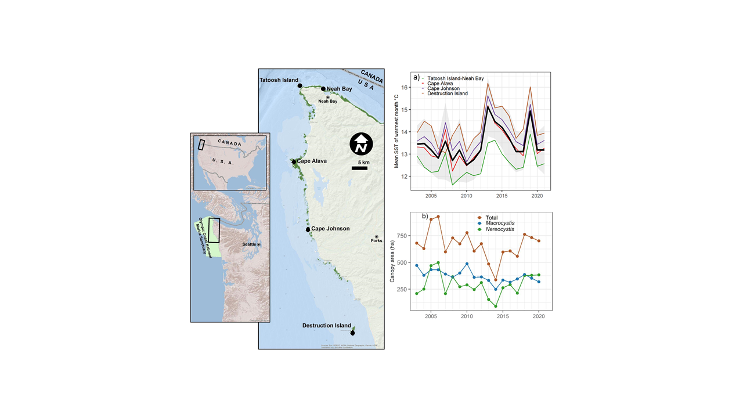

##### Figure 1. a-c) Location of Olympic Coast National Marine Sanctuary (OCNMS, the outer coast of Washington and the western Strait to Neah Bay) and the five study sites with distribution of floating kelp shown in green; d) Mean SST of the warmest month averaged across the five sites (black line); and e) total area of kelp canopies floating on the surface within OCNMS. Black line in (d) is the mean across sites; colored lines are mean SST of the warmest month by site; gray envelope is +/- 1.0 s.d.

##### Figure 2. Time series of the focal groups coastwide from dive surveys from 2015-2021. a) density of kelp stipes, b) urchin density, c) sea star density, d) fish abundance, and e) abundance of juvenile rockfishes. For sea stars see Table S4 for species included in the medium and large sea star categories.

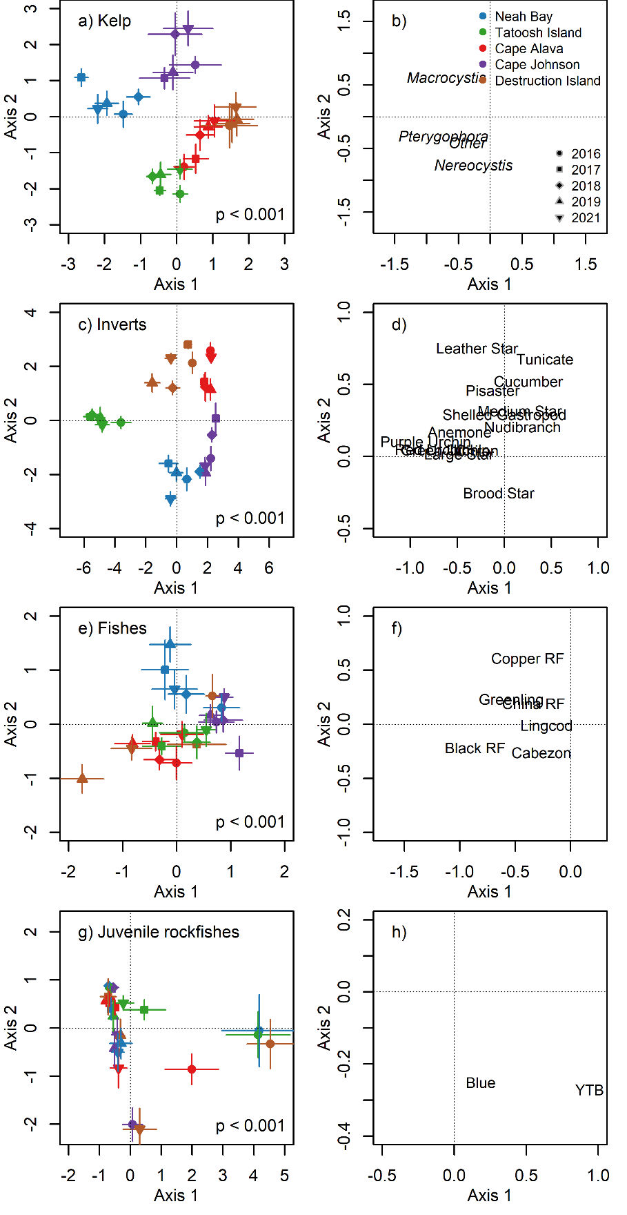

##### Figure 3. Results of canonical analysis of principal coordinates (CAP) of the assemblage structure of four guilds: kelps, invertebrates, fishes, and juvenile rockfishes. Left panes (a,c,e,g) show the ordination of Site x Year averages and p-values for the CAP analysis. Right panes (b,d,f,h) show the loadings for each taxon. RF = rockfish, YTB = yellowtail and black rockfishes.

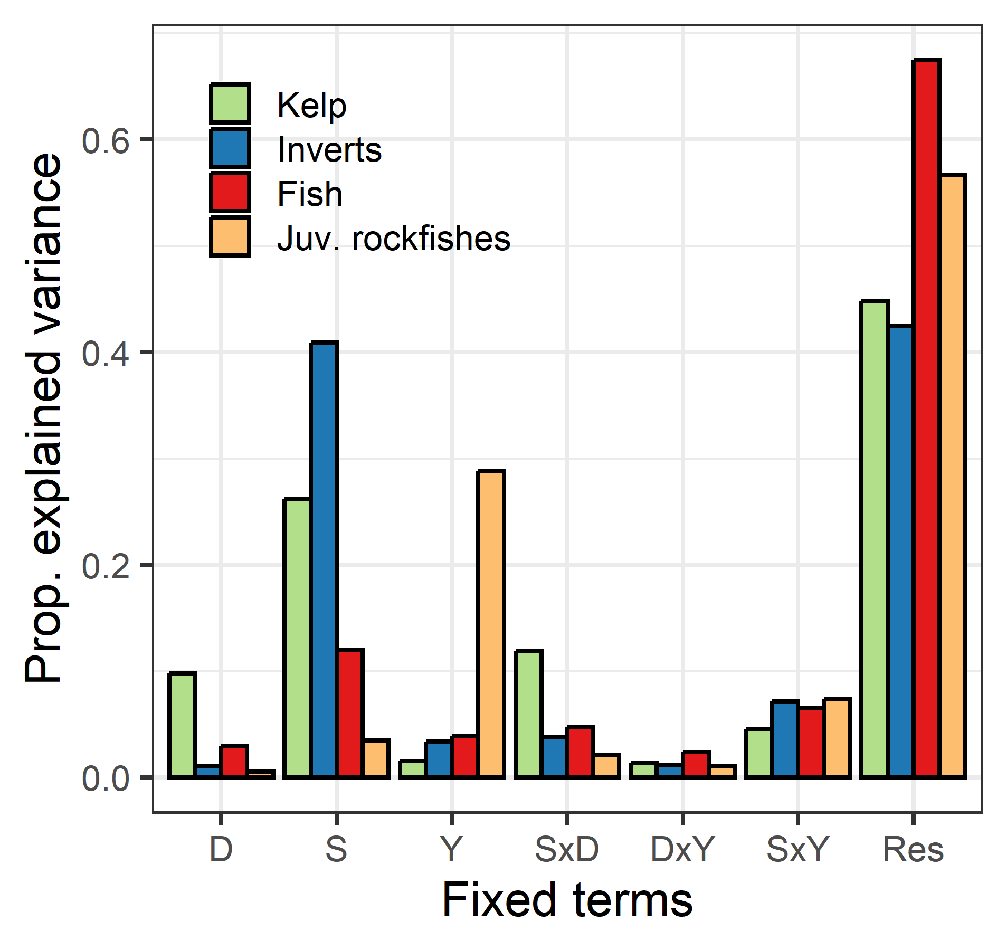

##### Figure 4. Explained variation from permutation-based multivariate analysis of variance (PerMANOVA) for four guilds: kelp, invertebrates, fish, and juvenile rockfishes. All terms are fixed effects and results are the r2 values. D = depth, S = site, Y = year, Res = Residual.

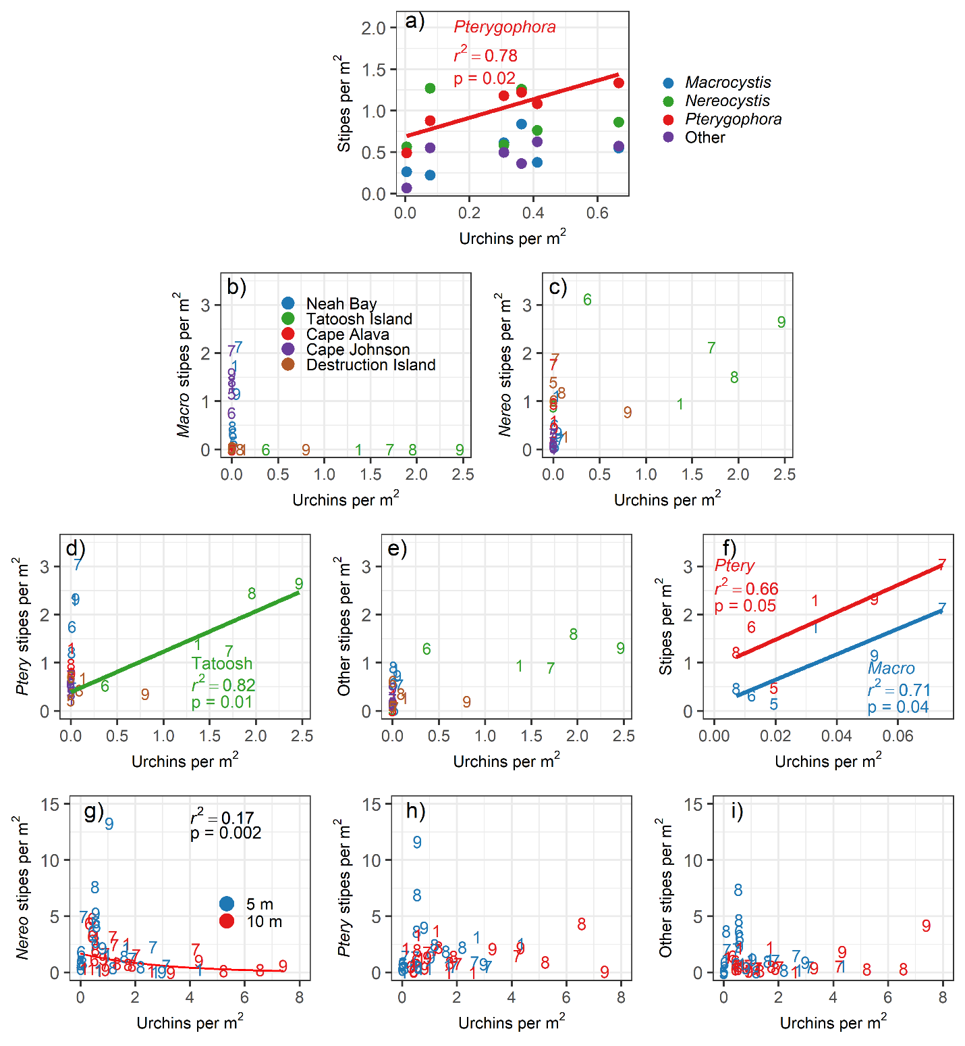

##### Figure 5. Relationship between the density of kelp stipes and total urchin density at different spatial scales: a) coastwide across years; Site by Year means for b) *Macrocystis*, c) *Nereocystis,* d) *Pterygophora,*, e) other stipitate kelps, and f) for *Macrocystis* and *Pterygophora* at Neah Bay to show pattern obscured by the scale in other panes; and at the transect level at Tatoosh Island for g) *Nereocystis,* h) *Pterygophora*, and ii) other stipitate kelps*.* For panel f the regression was for loge(Nereo stipes) = Urchin density. In panels b-i, numbered points refer to the year of data collection: 5 = 2015; 6 = 2016; 7 =2017; 8 = 2018; 9 =2019; 1=2021.

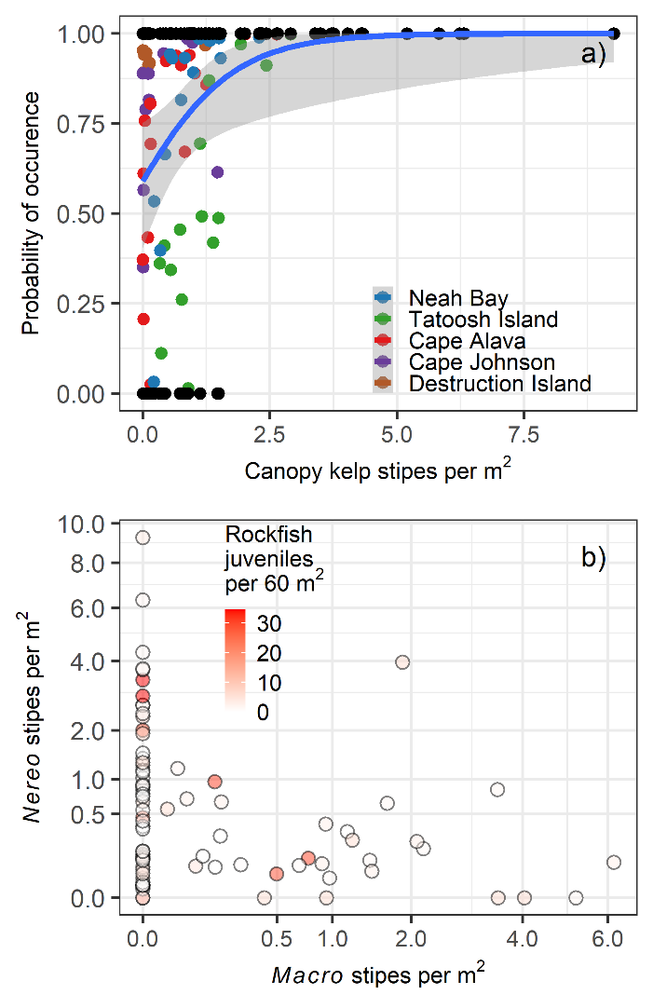

##### Figure 6. Relationship between kelp density and the abundance of juvenile rockfishes from the hurdle model. (a) Probability of occurrence of juvenile rockfishes in relation to the total stipe density of the canopy kelps *Macrocystis and Nereocystis*. Blue line shows the result of the binomial presence/absence model. Black points are the actual observations (present =1, absent = 0). Colored points are predicted probability of occurrence. (b) Results of the combined presence/absence model and abundance model. Larger circles have a higher probability of occurrence. Data were summarized by Site x Depth x Location x Year strata prior to analysis.